Translation manual

1. Install Babylon.NET – Translator <http://www.redpin.eu/download.html>

2. Set up “Google API Key” or “Azure account key” in settings window

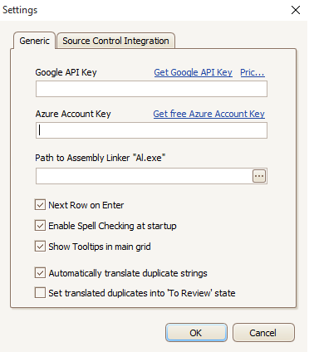

3. Open translation assignment file \*.btp

4. Using Automated translation select corresponding translator and automatically translate source to target language

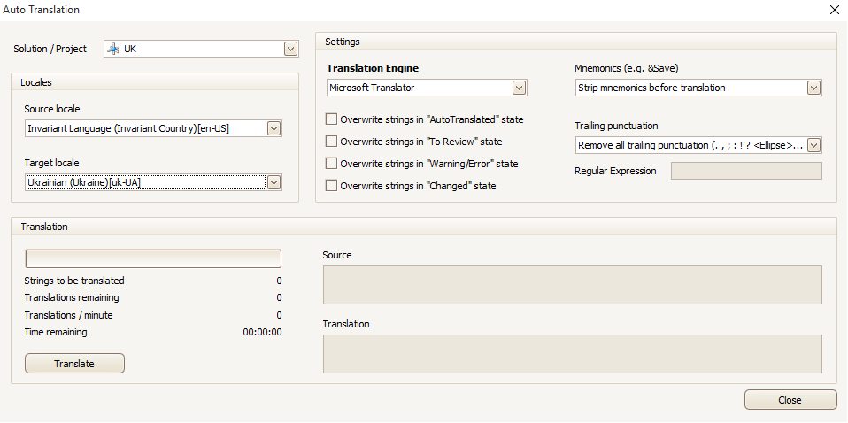

5. Check auto translation and fix if

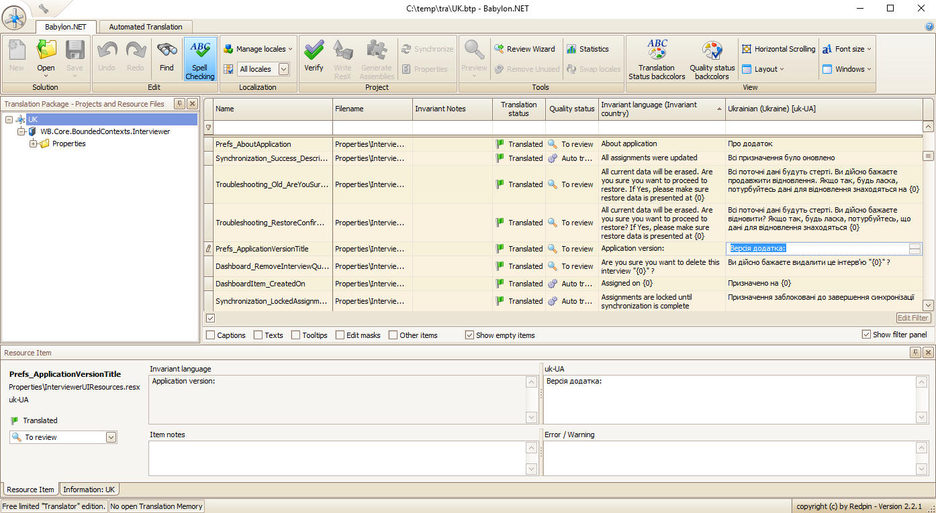

6. Please take a look on “Translating” help item. Either push quotation mark in upper corner of application and navigate to “Translating Visual Studio project”. You could try to copy to your browser this path: "file:///C:/Program%20Files%20(x86)/Redpin/Babylon.NET%20-%20Translator/help/index.html?translating.htm"

7. Save file

\*Please be advised that Ctrl+Z works incorrect in cell edit mode and rolls back previously changed cell